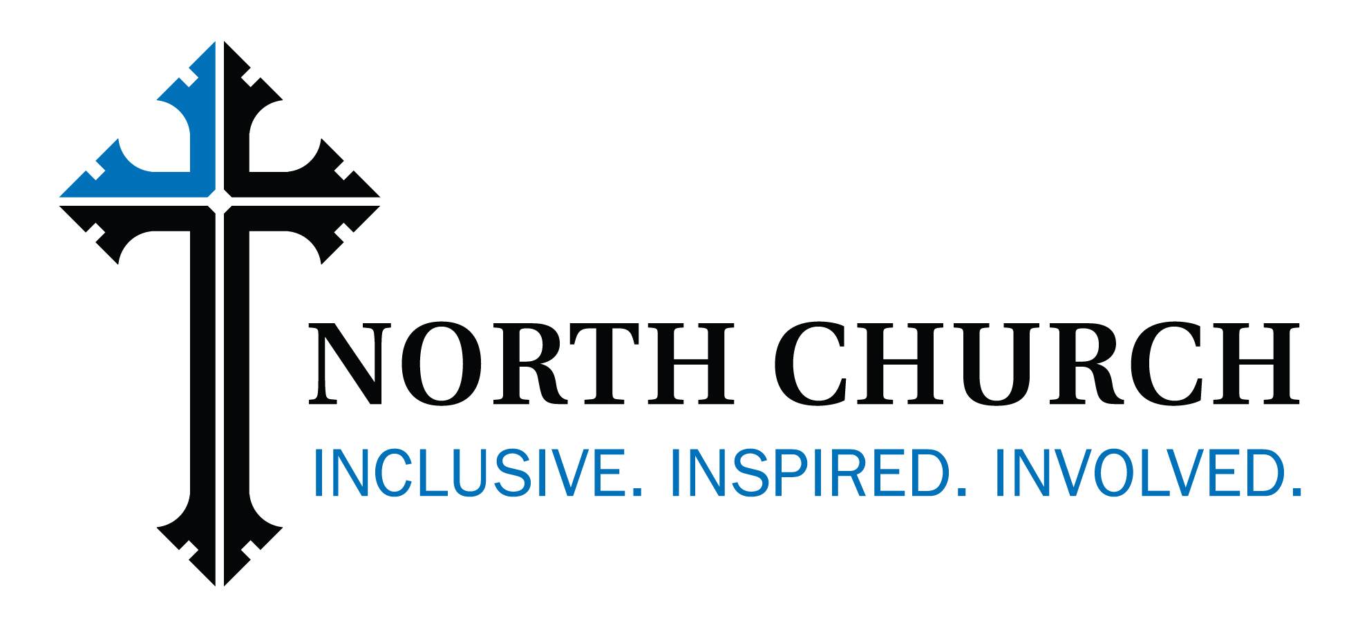
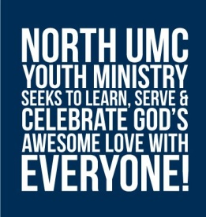

North UMC Youth
2016-17 Covenants

Event: All North UMC Youth Group Activities
Dates: August 2016 – July 2017

In signing this Covenant, I agree to live by the following guidelines, as established by North United Methodist Church and its Youth Council, during the above named experience.

I will:
• Respect the physical and emotional well-being of other youth and adults by “doing unto them as I would have them do unto me” (refraining from practical jokes, hurtful or threatening language and rough-housing, exercising common courtesy at all times).
• Be responsible for my own behavior and participate fully.
• Abide by adult and/or group decisions made during the experience.
• Respect the property where we are.
• Respect my personal boundaries, those of other persons, and those of our group by refraining from any action and/or language of a sexual nature that could be a violation of those boundaries.
• Respect the health of my own body by refraining from the use of tobacco, alcohol and drugs of any kind, except those prescribed by a physician. I will notify the Youth Minister of such prescription drugs and report to an adult immediately if I am injured such that I receive a bruise or bleed. I will also report immediately if I am not feeling well for any reason.

If the Covenant is violated, one or more of these consequences will be activated:
1. I will have a “heart to heart” with the adult leaders or the Youth Minister to help me choose more appropriate behavior options and to make amends with the group, or with an individual.
2. I will call my parents and tell them what happened. If necessary, I will return home.
3. I will participate in future events only when I have re-established trust with North Church, its Youth Minister, and my adult leaders.

Signed and Dated by:
Printed Name:

I will support my youth in keeping this covenant!

Parent signature and Date:
Printed Name:

