Prelude When I Survey the Wondrous Cross arr. R. Hobby

Greeting Darren Cushman Wood

*CALL TO WORSHIP
Leader: God is light, in whom there is no darkness at all.
People: Jesus Christ is the light of the world.
Leader: And this is the judgment,
that the light has come into the world,
People: but we loved the darkness rather than the light.

*Hymn #298 When I Survey the Wondrous Cross

The First Word Luke 22:34
“Father, forgive them, for they do not know what they are doing.”
O Come and Mourn With Me
O come and mourn with me awhile; O come ye to the Savior’s side; O come,
together let us mourn: Jesus, our Lord is crucified! Have we no tears to shed for
him, while soldiers scoff and foes deride? How patiently he hangs: Jesus, our
Lord is crucified. Seven times he spoke, seven words of love; and all three hours
his silence cried for mercy on the souls of all: Jesus, our Lord is crucified.
O love of God, O sin of man! In this dread act your strength is tried;
and victory remains with love: for he, our Love, is crucified!

Prayer on the First Word from the Cross
Gentle Father,
we do not know the consequences of our sins,
we cannot comprehend the damage we have done.
We are confused and tossed about.
All we know is our need of you.
Come to us in this hour,
and bring the forgiveness that will make us whole,
through Jesus our Lord whose crucified love
frees us from sin.
Amen.

The Second Word Luke 23:43
“Today, you will be with me in paradise.”
Hear Us, Holy Jesus
Hear us, holy Jesus. Jesus, pitying the sighs of the thief, who near thee dies,
promising him paradise: hear us, holy Jesus. May we in our guilt and shame
still thy love and mercy claim, calling humbly on thy name: hear us, holy Jesus.
May our hearts to thee incline, looking from our cross to thine; cheer our souls
with hope divine: hear us, holy Jesus.

Prayer on the Second Word from the Cross
Hear us, holy Jesus,
for we need the assurance of your never ending love.
Still our fears and capture our doubts
until all we can see and hear
is the joy of your hope
that outlasts our pain. Amen.

The Third Word John 19:26-27
Chancel Quartet
“Dear Woman, here is your son. Here is your mother.”
At the Cross, Her Station Keeping
At the cross, her station keeping, stood the mournful mother weeping, where he hung, the dying Lord; for her soul, of joy bereaved, bowed with anguish, deeply grieved, felt the sharp and piercing sword. O how sad and sore distressed now was she, that mother blessed, of the sole begotten One. Deep the woe of her affliction when she saw the crucifixion of her ever glorious Son. Jesus, may her deep devotion stir in me the same emotion, fount of love, Redeemer kind, that my heart, fresh ardor gaining and a purer love attaining, may with thee acceptance find.

Prayer on the Third Word from the Cross
O Fount of Love,
give us courage
to kneel with Mary
at the foot of the cross.
Stir in us the same desire
to risk our hearts being wounded
by sharing the anguish and affliction
of the Marys of today
who grieve their children’s pain. Amen.

The Fourth Word Matthew 27:46
“My God, My God, why have you forsaken me?”
Bound Upon the Accursed Tree
Bound upon the accursed tree, faint and bleeding, who is he? By the eyes so pale and dim, streaming blood and writhing limb? By the flesh with scourges torn, by the crown of twisted thorn, by the side so deeply pierced, by the baffled, burning thirst? Bound upon the accursed tree, dread and awful, who is he? By the sun at noonday pale, shivering rocks and rending veil? Lo! beneath the blackened sky, hear his last and bitter cry. Crucified, we know thee now: Son of God! ‘tis thou!

Prayer on the Fourth Word from the Cross
My God, my God, why have you forsaken me?
My doubts are too deep,
my questions too wide
for me to feel you now.
Yet, I still cry to you.
In the Crucified One
my doubts become acts of faith
and my questions draw me near to you.
In the name of Jesus I pray. Amen.

The Fifth Word John 19:28
“I am thirsty.”
Jesus, In Thy Thirst and Pain
Jesus, in thy thirst and pain, while thy wounds thy lifeblood drain; thirsting more
our love to gain. Thirst for us in mercy still, all thy holy work fulfill; satisfy thy
loving will. May we thirst thy love to know, lead us in our sin and woe, lead us
where the healing waters flow.

Prayer on the Fifth Word from the Cross
Faithful Savior,
You were thirsty so we could be comforted,
you were bound so we could be free,
you were stripped so we could be clothed in your love.
How can we fathom the mystery of your grace?
Quench now our thirst to know you
and lead us where the healing waters flow. Amen.

The Sixth Word John 19:30
“It is finished.”
O Perfect Life of Love
O perfect life of love, all is finished now; all that he left his throne above to do for
us below; all is finished now. No pain that we can share but he has felt its smart;
all forms of human grief and care have pierced that tender heart. All is finished
now. In perfect love he dies for me! O All-Atoning Sacrifice, I cling by faith to
thee.

Prayer on the Sixth Word from the Cross
God of unconquered love,
thank you for Jesus
who suffered and died for us
so that we can die in him and say
to our unresolved conflicts,
our unfulfilled desires,
and our unbearable sins:
“All is finished now” in Jesus Christ our Lord. Amen.

*Hymn #286 O Sacred Head, Now Wounded

The Seventh Word Luke 23:46
“Father, into your hands I commit my spirit.”
Behold the Lamb of God
Behold the Lamb of God, bowed down in bitter pain; to God his dying prayer
ascends. In death, my Lord and Savior, may I cry with thee: “My Father, I
commend my Spirit into thy loving hands.” I die in thee.

Prayer on the Seventh Word from the Cross
Faithful Sovereign, Merciful Savior, Eternal Spirit:
we offer ourselves as a holy and living sacrifice
in union with Christ’s offering for us
in this mystery of divine love.
Take us as we are and keep us in your grace.
We surrender everything to your will and way
that our lives may reflect your glory
through Jesus Christ who lives and reigns with you
and the Holy Spirit, one God, now and forever. Amen.

Tolling of the Bells

Each toll represents one of the thirty-three years of Jesus’ life.
After a moment of meditation, the congregation is asked to leave in silence.

The Happenings
_______________________________________________________________________________________________________________________________________________________________________________________________________________________________________________________________________________________________________________________________________________________________________________
For more information, please subscribe to our e-newsletter at www.northchurchindy.com or follow us on Facebook at www.facebook.com/northchurchindy or Twitter at @NorthChurchIndy
*Sign up for events at the Hospitality Desk*

Upcoming special worship events at North United Methodist Church:

- April 1: Easter Sunday
  - 8:30 a.m. - Holy Communion service.
  - 11 a.m. - The Carolers children’s choir and the Cathedral Singers will offer special music.
- May 6: Youth Sunday – 8:30 a.m. and 11 a.m. The Youth Group will lead the morning services through scripture, sharing faith stories, music and more. The theme is the continuation of the Lenten retreat theme, “The Anatomy of a Believer.”
- May 13: Foot Notes: A Mother’s Day Musical – 9:45 a.m. Our feet put in a lot of steps, but are they always on the right path? To the melodic notes of Irving Berlin, Duke Ellington and Broadway tunes, the Choristers and Carolers children’s choirs will share their talents in a Mothers’ Day musical you won’t want to miss!
- May 20: Harmony Mass by Franz Joseph Hayden – 8:30 a.m. and 11 a.m. Composed in 1802, we look forward to presenting this beautiful “classical” mass with orchestra and an enhanced wind section.
- June 24: Worship Without Walls – 11 a.m. Back by popular demand, we will gather under a tent in our parking lot for one service of celebration and music. Heather Bays returns to lead the music. Bring your friends and welcome our neighbors in the community.

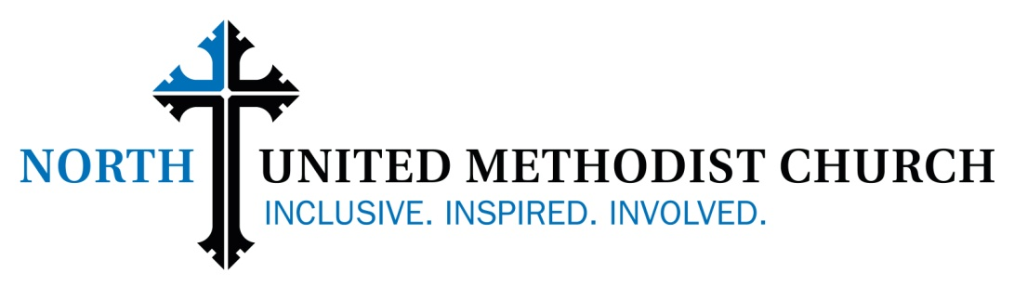

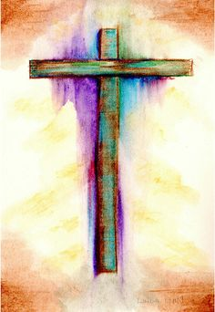

Good Friday, March 30, 2018
7:00 p.m.

North United Methodist Church is an open, inclusive,
and welcoming church. We affirm that through God’s
redeeming love, all are one in Christ.
YOU are welcome at North.

