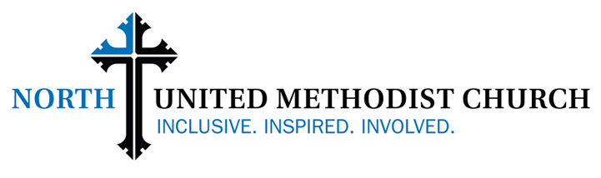 Job Description

Position Classifications
Minister of Youth and Young Adults Program Staff
Exempt
Supervisor Full-Time
Minister of Discipleship and Formation

FUNCTION
The Minister of Youth and Young Adults will serve the church by developing and coordinating effective and comprehensive ministries to and with youth and young adults, and providing leadership and supervision of staff members, lay leaders, and volunteers involved in this ministry area. Approximately ¾ time will be devoted to youth (grades six through twelve) and ¼ time will be devoted to young adults (age 18-30).
ORGANIZATIONAL RELATIONSHIPS
The Minister of Youth and Young Adults will report to and be reviewed by the Minister of Discipleship and Formation and relate to all pastoral and program staff and key church lay leaders in those areas of ministry.
ESSENTIAL DUTIES AND RESPONSIBILITIES SHALL INCLUDE:
- Cherish diversity and inclusivity at North Church and work effectively across cultural and economic boundaries
- Model and encourage professionalism in and through all interactions
- Multitask, showing an ability to do and to delegate
- Demonstrate a track record of results and commitments fulfilled
- Document, assess, and record outcomes using numeric metrics and descriptive language
- Operate ministries within the budget of the church
- Maintain and use a shared calendar
- Align youth and young adult ministries with those of North Church
- Practice, promote, and ensure ethical behavior in all interactions
- Attend and provide staff support for the Youth Council and ministry team(s) for young adult ministries
- Attend, participate in, and report to the Ministries Council, staff meetings, and other meetings as assigned by the Senior Pastor
- Other duties, as assigned
Youth Ministries:
- Lead in exploring ways to expand and improve existing youth ministries to include transformative practices of spiritual formation and servanthood
- Overseeing all aspects of youth ministry, including but not limited to Sunday School, United Methodist Youth Fellowship, confirmation, retreats, special events, and mission projects and mission trips.
- Reaching out and extending fellowship to youth who are beyond the immediate North church family
- Facilitating the integration of youth with disabilities and special needs.
- Creating opportunities for youth to explore their callings and vocations.
- In collaboration with the Senior Pastor, providing pastoral care for youth and their families.
- Recruiting, training and supervising lay adult leadership in youth ministries.
- Selecting/developing age-appropriate material for instruction regarding youth stewardship, sacraments, Scripture, membership, and liturgical year.
- Scheduling all volunteers and teachers and finding substitutes when necessary.
- Coordinating communication for youth ministry with the congregation and the community.
- Supervising interns who are assigned to work with youth.
- Collaborate with other ministry areas to integrate and align mission and outreach initiatives for maximizing the overall vision of the church.
- Theologically interpret and articulate the role of youth and young adult ministries to the congregation.
Young Adult Ministries:
- Developing, resourcing and supervising new ministries with and for young adults.
- In collaboration with the Senior Pastor, providing pastoral care for young adults.
- Reaching out and extending fellowship to young adults who are beyond the immediate North church family
- Coordinating communications that target young adults.
- Collaborating with other congregations and organizations for young adult ministries.
Relating to Both Youth and Young Adult Ministries:
- Develop and maintain a communication process for assigned ministry areas to ensure effective flow of information
- Develop action plans for the recruitment, development, and retention of lay church leaders serving in youth and young adult ministries
- Working with the Minister of Discipleship and Formation to create continuity of ministries in all areas
- Participating, as needed, in Sunday morning services as liturgist and other worship experiences.
QUALIFICATIONS, SKILLS, AND ABILITIES – Eligibility for this position requires that the person have already demonstrated the following:
- Strong support of North Church’s ministry and mission
- Passion for youth and young adult ministries
- Demonstrated skill in maintaining confidentiality
- Entrepreneurial spirit and creativity for developing new ministries
- Self-motivation to accomplish goals in an intelligent, compassionate, and trusting work environment
- Excellent communication skills
- Ability to constructively handle stress and pressure
- A strong team-orientation that relates comfortably and confidently to church leadership, peers, and subordinates, cultivating strong, quality relationships for the church and its leaders
EDUCATION AND/OR EXPERIENCE
- Bachelor degree with substantial youth ministry experience required
- Preference for Master of Arts in Youth Ministries or Master of Divinity degree
COMPENSATION

- Salary commensurate with experience and education. Benefits include 403b contribution, paid vacation time, and available continuing education funds. Health insurance negotiable.

APPLICATION INFORMATION

- Send resume and cover letter, including experience to: North United Methodist Church, Amy Sell, asell@northchurchindy.com with subject: “Minister of Youth and Young Adults Application” Check out our website at www.northchurchindy.com.

DEADLINE
- Applications accepted until position is filled

