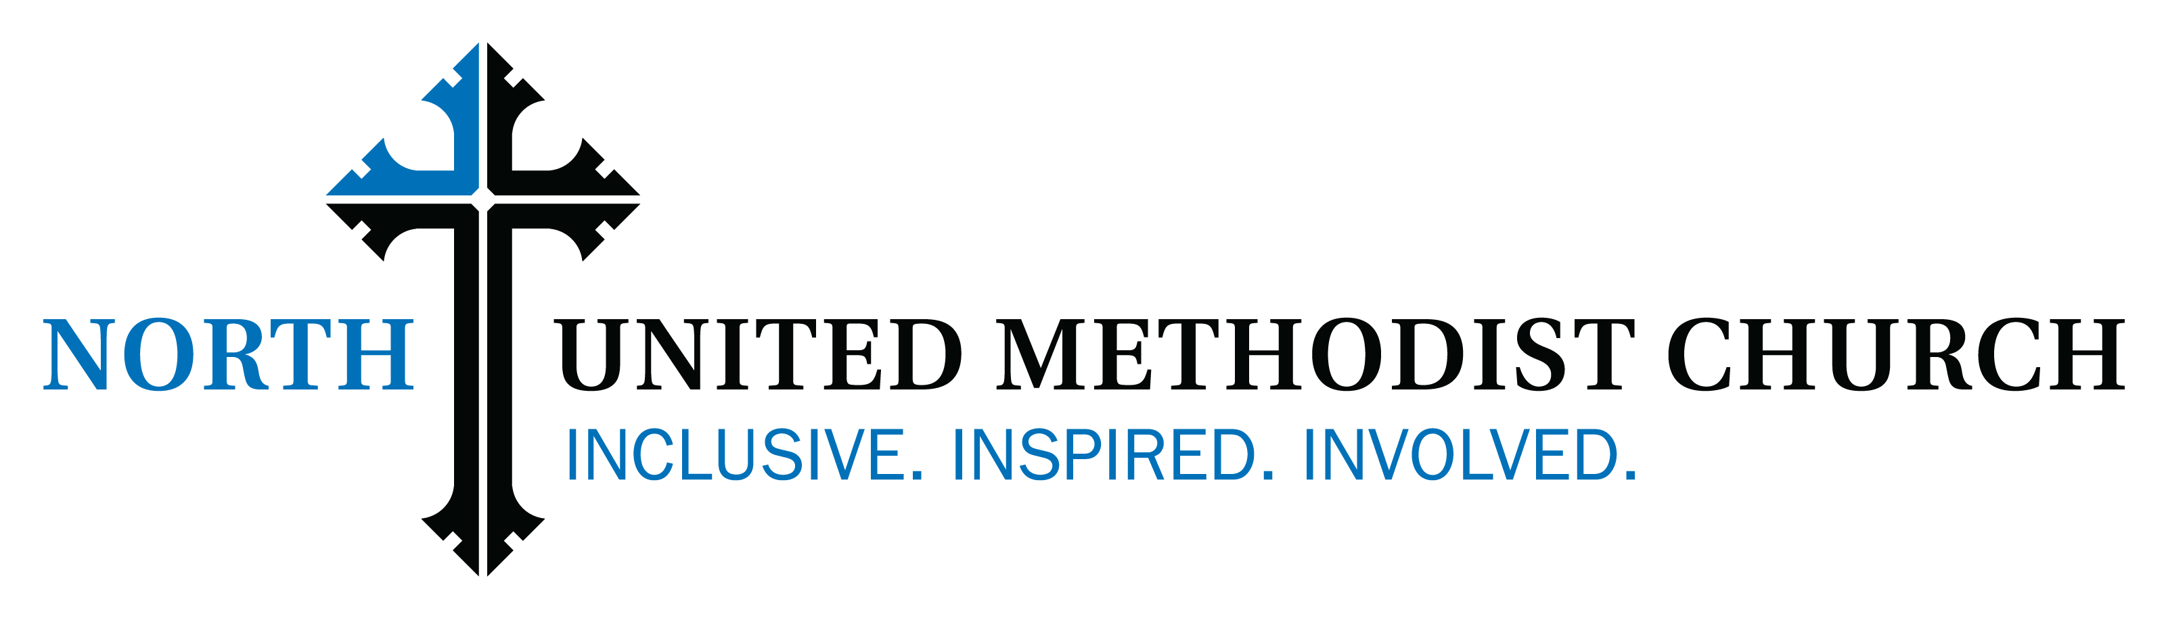

General Building Protocol – July 8, 2020

North United Methodist Church (North) strives to provide a healthy and safe environment for its congregation. In order for this to occur the following protocol has been established for general building operation due to the COVID-19 pandemic.

General:

Access to the building is limited to essential personnel and staff during the regular workweek. The “Protocols for Working in North UMC for Staff and Clergy” went into effect on June 18, 2020 and still applies. Access is given to contractors that are considered business critical: HVAC, elevator maintenance, building inspectors, fire marshal and cleaning services employees shall read, sign and follow the protocol for contractors. Non-business-critical contractors’ presence in the building is to be reviewed and approved by the building manager.

The wearing of masks or facial covering is required in the building unless otherwise specified by the building manager or senior pastor.

Restrooms:

The Community Room restrooms will be the primary area for public and church member use during regular weekly attendance. These restrooms are to be cleaned and disinfected per the protocol for “Return to Worship Service – Disinfecting Policy for Surfaces.” Restrooms in the remainder of the building are limited to staff only.
Kitchens:
The kitchens in the church have been appropriately cleaned using established guidelines managed by the facility staff and available from the head custodian. At this time NO FOOD PREPARATION OR SERVICE will be performed in the building using church kitchens with the exception of that associated with the “Bread and Bowl” mission.

Weddings and Funerals:
Weddings and funerals will follow the protocols outlined for worship services (a copy of the worship protocols will be shared during the planning of these services). No visitations or receptions are allowed at this time.
Available Meeting Rooms (Essential Rooms):
The sanctuary, chapel, parlor and Fellowship Hall are deemed essential rooms. These rooms are appropriately marked or managed to maintain appropriate social distancing. The current seating capacity is as follows:
Sanctuary: 50
Chapel: 20
Parlor: 12
Fellowship Hall: 45
Classrooms and Other Non-Essential Rooms:
All classrooms and other non-essential rooms have been thoroughly cleaned and disinfected. Entrance to these rooms is strongly discouraged, as this would require they be identified to the custodial staff for a subsequent re-cleaning and disinfecting. These rooms have not been set up for social distancing.

